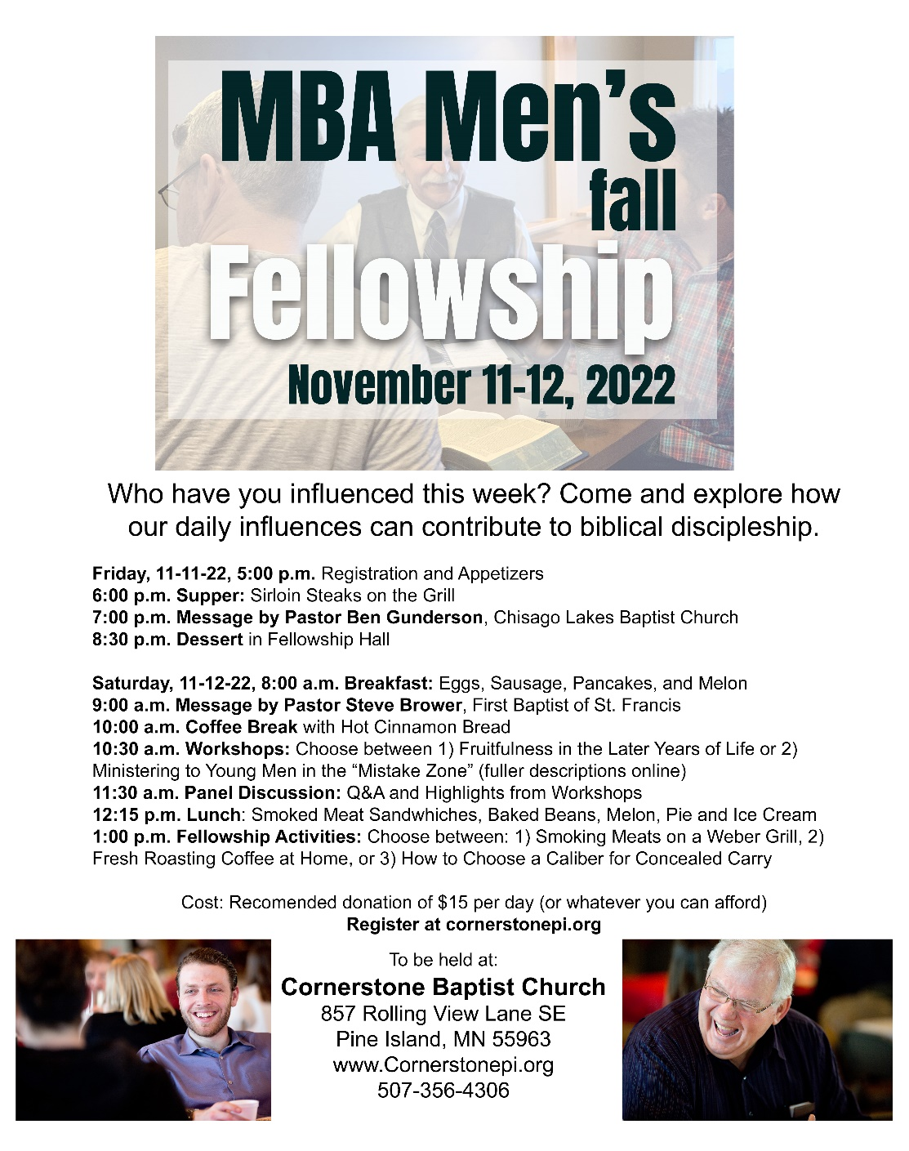
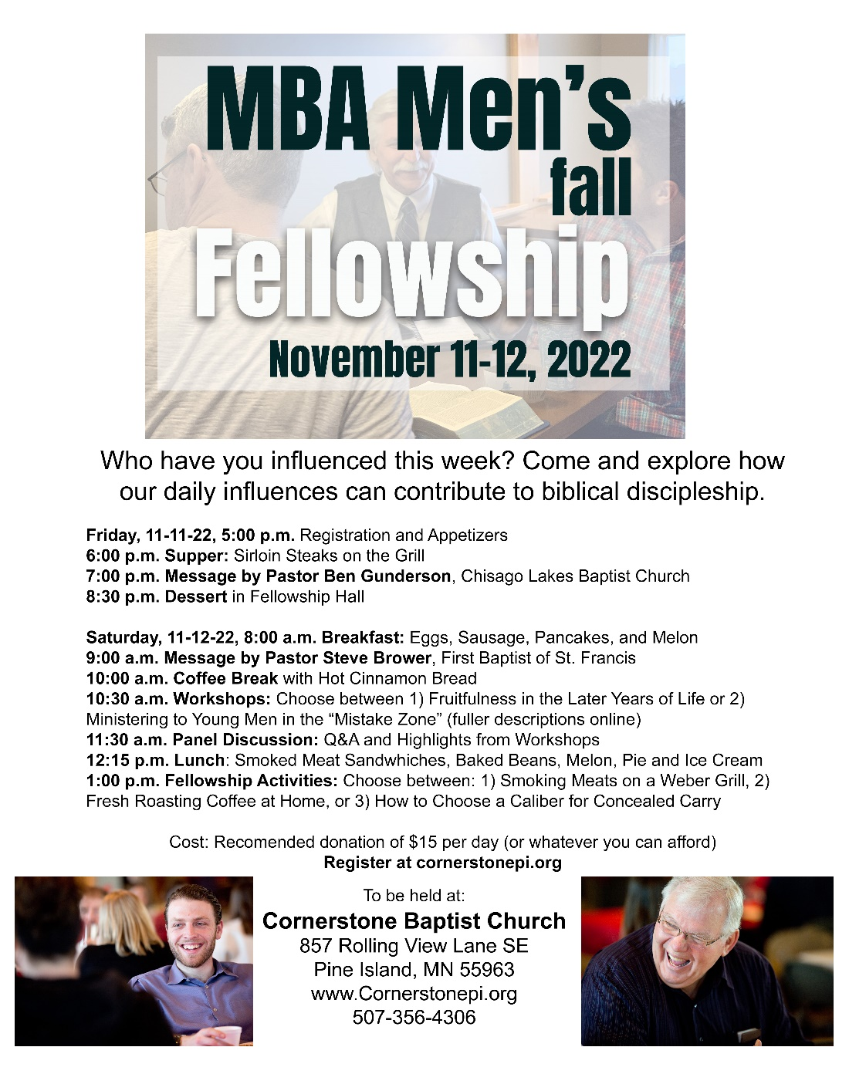

Breakout Session Details:
- Fruitfulness in Retirement – A discussion on fruitfulness in the “retirement” years. How to avoid irrelevance as a child of God and member of society and maintaining importance in our roles. A discussion informed by JI Packer’s “Finishing Our Course with Joy.”

- Ministry in the “Mistake Zone” – Young people, especially men ages 17 to 27, are increasingly virtual and decreasing participation in public life, marriage, and even rites of passage like obtaining a drivers’ license. Yet these are “men” in every definition of the word and nothing sanctifying will happen without them choosing it for themselves with the Holy Spirit’s aid. What is our part? One thought is to place strategic stepping stones that might into adult life should they choose it. A warning is to not place manipulations or stumbling stones ahead of them that would trip them up. Young people ages 17-27 are most welcome to attend and inform this session.

Hotels Nearby by Lowest Price:
Microtel, 4210 Highway 52 North, Rochester, MN 55901
(507)218-7924

Country Inn & Suites, 4323 Hwy 52 North, Rochester, MN 55901
(507)218-9559

TownePlace Suites, 2829 43rd St NW, Rochester, MN 55901
(507)281-1200

Breakout Session Details:
- Fruitfulness in Retirement – A discussion on fruitfulness in the “retirement” years. How to avoid irrelevance as a child of God and member of society and maintaining importance in our roles. A discussion informed by JI Packer’s “Finishing Our Course with Joy.”

- Ministry in the “Mistake Zone” – Young people, especially men ages 17 to 27, are increasingly virtual and decreasing participation in public life, marriage, and even rites of passage like obtaining a drivers’ license. Yet these are “men” in every definition of the word and nothing sanctifying will happen without them choosing it for themselves with the Holy Spirit’s aid. What is our part? One thought is to place strategic stepping stones that might into adult life should they choose it. A warning is to not place manipulations or stumbling stones ahead of them that would trip them up. Young people ages 17-27 are most welcome to attend and inform this session.

Hotels Nearby by Lowest Price:
Microtel, 4210 Highway 52 North, Rochester, MN 55901
(507)218-7924

Country Inn & Suites, 4323 Hwy 52 North, Rochester, MN 55901
(507)218-9559

TownePlace Suites, 2829 43rd St NW, Rochester, MN 55901
(507)281-1200

